**CROP PROTECTION FROM BIRDS USING CNN**

**Using Convolution Neural Networks**

Developed by: Chahat Tandon, Jaina H Shah ,Ksheera P B ,Preethi R,Swathi R

**Smart Bridge-Remote Summer Internship Program**

1. **INTRODUCTION**

Smart farming is important for tackling various challenges of agricultural production such as productivity, environmental impact,and crop protection, food security and sustainability. As the global population is growing continuously a large increase of food production must be achieved. This must be accompanied with the protection of natural ecosystems by means of using sustainable farming procedures. Food needs to maintain a high nutritional value while its security must be ensured around the world .Crop damage by animal intrusion is one of the major threats in lessening crop yield. The farm areas near the forest boundaries are prominently affected by the wild animal attacks. Agriculture plays a major role in the development of a country. Issues concerning agribusiness have been continually thwarting the advancement of the nation. Farmers face a huge number of issues, for example, insufficiency of water for irrigation, crops withering because of climatic changes, soils lacking in nutrients and harm to crops because of pests and wildlife. The productivity is decreased by the wild creatures trampling over harvests and eating them. This project provides a solution for these problems without hurting creatures or setting human life at stake.

Classification of the intruded animals as local or wild animals is done using the photos taken utilizing Convolutional Neural Network. CNN a special architecture of artificial neural networks model is mainly used for classification of images. After classification is done accordingly sounds are used to ward off the creature and an SMS is sent on account of the wild creature to the landowner. Data regarding these intrusions of wild and domestic creatures are sent to the cloud by means of the web. This way it is easy to arrive at useful information regarding the intrusions and take measures against it.

Hence this approach is helpful to the farmers in protecting fields, saving them from financial losses.

**1.1 OVERVIEW**

A survey of CNN-based research efforts applied in the agricultural domain was performed: it examined the particular area and problem they focus on, listed technical details of the models employed, described sources of data used and reported the overall precision/accuracy achieved. Convolutional neural networks were compared with other existing techniques, in terms of precision, according to various performance metrics employed by the authors. The findings indicate that CNN reached high precision in the large majority of the problems where they have been used, scoring higher precision than other popular image-processing techniques. Their main advantages are the ability to approximate highly complex problems effectively. We use CNN to approximate a problem of identifying which bird or animal is responsible for eating or damaging the crops. Agriculture is the most important sector of Indian Economy but the issue of damage to crops by wild creatures has turned into a noteworthy social issue in current occasions.

**1.2 PURPOSE**

Our aim from the project is to make use of tensorflow and keras libraries from python to extract the libraries for deep learning application on the image classification. Currently, most farmers use wire fences or electric fences to prevent animals from entering the farmland. Electric fences hurt animals by inflicting shock and are a possible fire hazard so it's helpful to agriculture fields. We use CNN for this purpose.

1. **LITERATURE SURVEY**

**(A) Design and Implementation of an Intelligent Security System for Farm Protection from Wild Animals**

This paper has proposed a system to detect motion on animals intrusion in farmland and ward it away with light. The proposed strategy to shield farmlands from wild creatures by means of ubiquitous wired system gadgets, which is used alongside conventional strategies to improve the protection. Operational amplifier circuits are used basically for the discovery of the creature intruding from the outside of the fields. The checking plan is to give early cautioning about the possible intrusion and harm by wild creatures. Fencing wire is used as a sensor. When there is interaction of animals with the open link an input signal is generated initially that shows that an animal is detected at fencing. For getting the resistance of fencing a microcontroller block is used. Entire procedure is constrained by the microcontroller. The GSM module is utilized for sending SMS to the owner thereby cautioning that there is an intrusion.

**(B)Prevention of Intrusion of Wild Animals in the Crop Fields**

The creatures from different regions are ceaselessly assaulting the harvest fields throughout the years and the security of these farm fields has turned into a fundamental concern. The strategies that previously being utilized is insufficient, in this article we are exhibiting a down to earth technique to ward them off, by making a framework which detects the animals, identifies the animal and makes the distinctive sound that bothers the creature and furthermore cautions the approved individual by sending sms. They additionally give a multi-class classification by showing zero false alert rate and accurately identifying the species. The purpose of this proposed framework is to distinguish the bird image processing and send a caution sms to the owner by means of GSM module.

**(C) Image net classification with deep convolutional neural networks**

In this paper we have classified high resolution images into five different classes by training a large CNN network. They concluded that the accuracy of the network is 97%. We have trained the models using ADAM approach.

**2.1 Existing problem**

Before the beginning of every farm season, most farmers prefer to plan potential yields. On the other hand, some farmers choose to skip planning. Whether a farmer plans the potential yield or not, certain expectations are still present. While hoping for the best, farmers are often presented with various challenges and obstacles that require them to constantly question their productivity and resulting final success. The greatest importance is usually given to crop protection from diseases, insect pests, and weeds, as well as to protection from unfavourable weather events such as frost or hail ,along with other crop maintenance practices. The aforementioned challenges are well-known and often discussed.

Crop damage due to animal intrusion is a critical problem faced by farmers in many parts of India, especially in areas near national parks and wildlife sanctuaries. It is not possible to manually monitor agricultural lands 24x7.

However, farmers also face another interesting challenge, often forgotten about or not realized; wild animal crop protection. Wild animals are a special challenge for farmers throughout the world. Animals such as deer, wild boars, rabbits, moles, elephants, monkeys, and many others may cause serious damage to crops. They can damage the plants by feeding on plant parts or simply by running over the field and trampling over the crops. Therefore, wild animals may easily cause significant yield losses and provoke additional financial problems. Another aspect to consider is that wild animal crop protection requires a particularly cautious approach. In other words, while utilizing his crop production, every farmer should be aware and take into consideration the fact that animals are living beings and need to be protected from any potential suffering.

**2.2 Problem Solution**

**Deep Learning (CNN):**

Our main goal is to develop an Image classifier using convolutional neural networks.The proposed system will monitor the entire crop at regular intervals through a camera which will be recording the surroundings throughout the day. Once the frame matches our data then it will send information to the farmer and will produce an appropriate sound or alarm to the person who hands over that. This ensures complete safety of crops from wildlife animals thus protecting the crops loss. Hence CNN is used to train the animal images.

1. **THEORETICAL ANALYSIS**

When it comes to Machine Learning, [Artificial Neural Networks](https://www.geeksforgeeks.org/implementing-ann-training-process-in-python/) perform really well. Artificial Neural Networks are used in various classification tasks like image, audio, words. Different types of Neural Networks are used for different purposes, for example for predicting the sequence of words we use Recurrent Neural Networks more precisely an LSTM, similarly for image classification we use **Convolution Neural Network**.

To achieve our goal, we have used one of the famous machine learning algorithms out there which is used for Image Classification i.e. Convolutional Neural Network(or CNN).As we know its a machine learning algorithm for machines to understand the features of the image with foresight and remember the features to guess whether the name of the new image fed to the machine. At first we created our very own dataset which includes the images of 5 different bird species i.e hens, hummingbirds, owls, doves and parrots. Now after getting the data set, we preprocess the data a bit and provide labels to each of the images provided.

**Libraries used:**

* DataGenerator- The ImageDataGenerator is an easy way to load and augment images in batches for image classification tasks.
* tensorflow – To add layers as well as compare the loss and adam curve our result data or obtained log.

**Layers used to build ConvNets**

A covnets is a sequence of layers, and every layer transforms one volume to another through differentiable functions.

Types of layers:

1. **Input Layer**: This layer holds the raw input of the image.
2. **Convolution Layer:** This layer computes the output volume by computing dot product between all filters and image patches.
3. **Activation Function Layer**: This layer will apply element wise activation function to the output of the convolution layer. Some common activation functions are RELU: max(0, x), Sigmoid: 1/(1+e^-x), Tanh, Leaky RELU, etc. We have used RELU as well as softmax for our model as this is a multi classification problem.
4. **Pool Layer:** This layer is periodically inserted in the covnets and its main function is to reduce the size of volume which makes the computation fast, reduces memory and also prevents from overfitting. Two common types of pooling layers are max pooling and average pooling.
5. **Dense layer** - It is the regular deeply connected neural network **layer**

Accuracy is defined as the ratio of the number of samples correctly classified by the classifier to the total number of samples for a given test data set.

We have used Non Linearity (ReLU) activation function. ReLU stands for Rectified Linear Unit for a non-linear operation. The output is *ƒ(x) = max(0,x).*ReLU’s purpose is to introduce non-linearity in our ConvNet. Since, the real world data would want our ConvNet to learn would be non-negative linear values. We have used the softmax function as this is a multi class classification problem.

**3.1 Block Diagram**

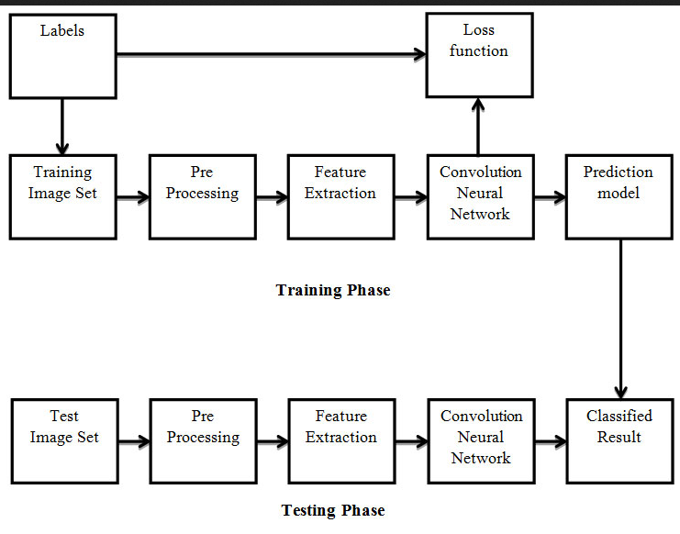

**3.2 Software Designing**

● Jupyter Notebook Environment

● Spyder Ide

● Machine Learning Algorithm (CNN)

● Python

● HTML

● Flask

We developed this crop protection from animals by using the Python language which is an interpreted and high level programming language and using the Machine Learning algorithms. For coding we used the Jupyter Notebook environment of the Anaconda distributions and the Spyder, it is an integrated scientific programming in the python language. For animal prediction we used the Flask. It is a micro web framework written in Python. It is classified as a microframework because it does not require particular tools or libraries. It has no database abstraction layer, form validation, or any other components where pre-existing third-party libraries provide common functions, and a scripting language to create a web page is HTML by creating the templates to use in the functions of the Flask and HTML.

**4. EXPERIMENTAL INVESTIGATION**

In this project,the dataset we used is downloaded from some datasets available on Kaggle. It contains five different species i.e dove,eagles,hens,owl,crows. The dataset consists of a total 1595 images of 5 different types of birds. The screenshot of the dove data set has been attached below:

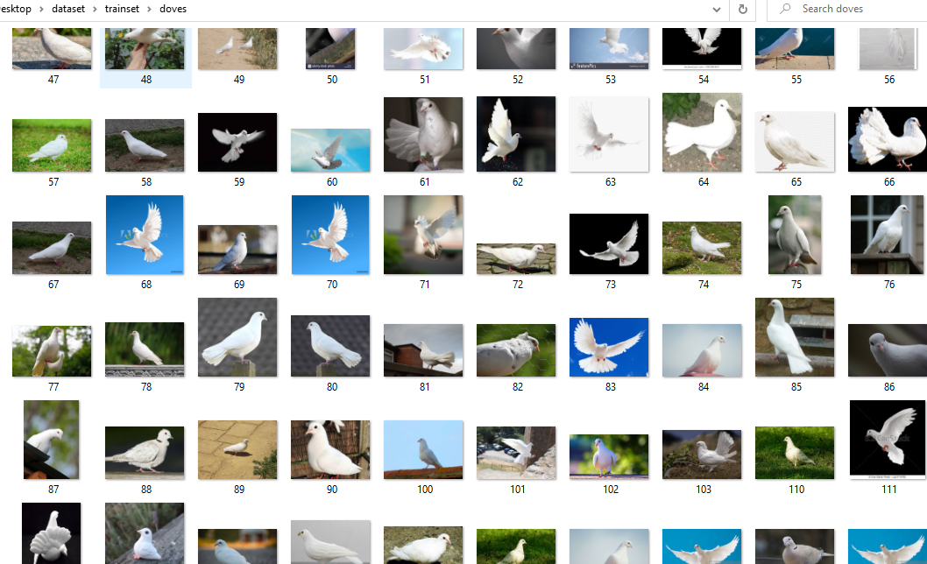

**5. FLOWCHART**

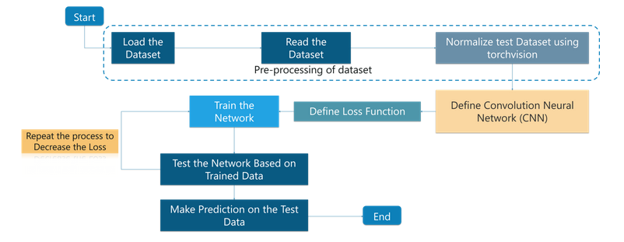

**6. RESULT**

We trained and tested our algorithms on the complete data set to start with. Later we randomly separated the data set into training data and test data so that we had samples from each class.80% of data is used for training data and 20% is used for test data. The dataset consists of 1595 pictures of these birds,and was used as a development set for CNN. The model was able to classify more than 90% of the images.The testing accuracy of the system is about 97%. Depending on the classification, the message and details will be sent over to produce sound or alarm to the person who hands over that department.Thus safeguarding the crops. The following figures and tables show the results we observed:

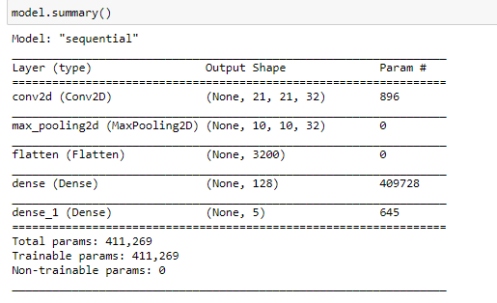

Fig 1- Model summary

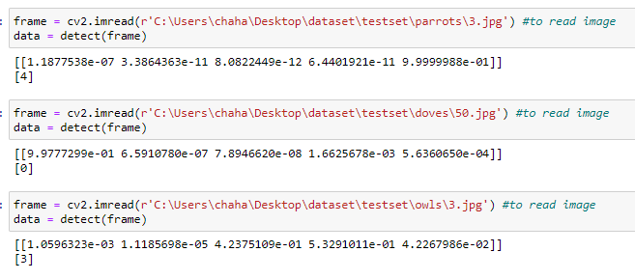

Fig2 - Predictions on ipynb

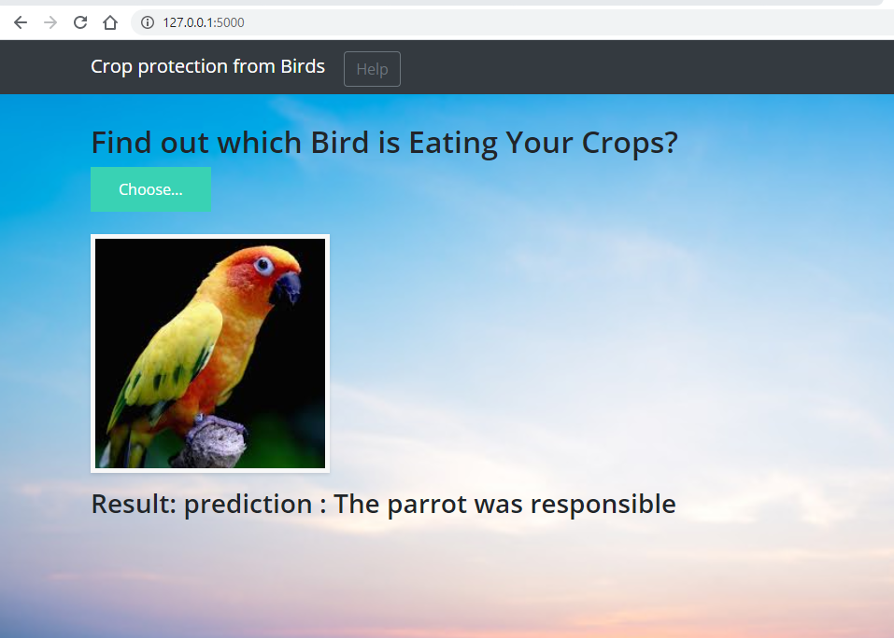

Fig 3- Predictions on the flask application

**7. ADVANTAGES AND DISADVANTAGES**

**Advantages:**

* Except from the improvements in precision observed in the classification/prediction problems at the surveyed works, there are some other important advantages of using CNN in image processing. Previously, traditional approaches for image classification tasks were based on hand-engineered features, whose performance and accuracy greatly affected the overall results. Feature engineering (FE) is a complex, time-consuming process which needs to be altered whenever the problem or the data set changes. Thus, FE constitutes an expensive effort that depends on experts’ knowledge and does not generalize well.
* Convolutional neural networks seem to generalize well and they are quite robust even under challenging conditions such as illumination, complex background, size and orientation of the images, and different resolution. It helps farmers to identify which animals are causing harm to their crops.so They can take preventive measures.
* Our model doesn’t harm animals as it only uses sound to scare them away.

**Disadvantages:**

* The main disadvantage is that CNN can sometimes take much longer to train. However, after training, their testing time efficiency is much faster than other methods
* Other disadvantages include problems that might occur when using pre-trained models on similar and smaller data sets, optimization issues because of the models’ complexity, as well as hardware restrictions.

**8. APPLICATIONS**

* We are developing a system that will monitor the entire crop at regular intervals through a camera which will be recording the surroundings throughout the day.
* Once the frame matches our data then it will send information to the farmer and will produce an appropriate sound or alarm to the person who hands over that.
* This ensures complete safety of crops from wildlife animals thus protecting the crops loss.Here CNN is used to train the animal images.

**9. CONCLUSION**

Prototype of a smart farm protection system has been developed which distinguishes the animals and can be used to ward them off. Nowadays the issue of farm vandalization by wild creatures has turned into a major social issue. It requires dire consideration as no viable solution exists till date for this issue. As our project plans to address this issue it carries a great social significance. This project is exceptionally viable in driving off the animals from the fields and keeps them away. It precisely detects the animals in the fields and sounds the buzzer. An ultrasonic buzzer can be used thereby preventing noise pollution. Once the intrusion had been detected using, the camera was triggered to capture an image. The harvests are harmed through 5 bird species. Hence, the dataset which consisted of 1395 pictures of these birds, was used as a development set for CNN. The CNN was tested with various test images including images taken by mobile cameras. CNN was able to classify more than 80% of the birds perfectly well.

**10. FUTURE SCOPE**

For future work, it is planned to apply the general concepts and best practices of CNN, as described through this survey, to other areas of agriculture where this modern technique has not yet been adequately used. Implementation of the smart farm protection system can be done in a large scale also with multiple sensors at different nodes. This will save and alert the people nearby. As a future work, if latency needs to be very low, edge/fog computing can be used. Usage of an ultrasonic buzzer will prevent noise pollution and disturbances to the neighbours. Solar powered batteries can be used to supply the system which makes this prototype eco friendly too.

**11. BIBLIOGRAPHY**

1. Prof. A.V. Deshpande. (2013). Design and Implementation of an Intelligent Security System for Farm Protection from Wild Animals.

2. M. Gogoi and S.R. Philip.Protection of Crops from Animals using an Intelligent Surveillance System.

3. Crop Protection by an alert Based System using Deep Learning Concept by Pooja MR.